ABSTRACT
The purpose of the mini project entitled as “HOSPITALS AND MEDICAL FACILITIES” is to computerize the Front Office Management of Hospital to develop software which is user friendly simple, fast, and cost – effective. It deals with the collection of patient’s information, diagnosis details, etc. Traditionally, it was done manually. The main function of the system is register and store patient details and doctor details and retrieve these details as and when required, and also to manipulate these details meaningfully System input contains patient details, diagnosis details, while system output is to get these details on to the screen. The Hospital Management System can be entered using a username and password. It is accessible either by an administrator or receptionist. Only they can add data into the database. The data can be retrieved easily. The data are well protected for personal use and makes the data processing very fast.

ACKNOWLEDGEMENT
There is always a sense of gratitude which people express towards other for their help and supervision in achieving the goals. This formal piece of acknowledgement is an attempt to express the feeling of gratitude towards people who helped us in successfully completing our mini project. We would like to express my deepest gratitude to Prof. Laxman Pawar/Ajit Suryanwanshi/Khade Mam, our guide for their constant co-operation, They were always there with competent guidance and valuable suggestions throughout the pursuance of this presentation.
We would also like to appreciate all the respondents and group members whose responses and coordination were of utmost importance and who helped us a lot in the collection necessary information. Above all no words can express our feelings to our parents, friends and all those people who supported us during the course of our mini project.

1.INTRODUCTION
The project Hospital Management system includes registration of patients, storing their details into the system, and also computerized billing in the pharmacy, and labs. The software has the facility to give a unique id for every patient and stores the details of every patient and the staff automatically. It includes a search facility to know the current status of each room. User can search availability of a doctor and the details of a patient using the id.
The Hospitals and medical facilities can be entered using a username and password. It is accessible either by an administrator or receptionist. Only they can add data into the database. The data can be retrieved easily. The interface is very user-friendly. The data are well protected for personal use and makes the data processing very fast.
and medical facilities is powerful, flexible, and easy to use and is designed and developed to deliver real conceivable benefits to hospitals.
Hospital and medical facilities is designed for multispeciality hospitals, to cover a wide range of hospital administration and management processes. It is an integrated end-to-end Hospital and medical facilities that provides relevant information across the hospital to support effective decision making for patient care, hospital administration and critical financial accounting, in a seamless flow.
Hospital and medical facilities is a software product suite designed to improve the quality and management of hospital management in the areas of clinical process analysis and activity-based costing. Hospital Management System enables you to develop your organization and improve its effectiveness and quality of work. Managing the key processes efficiently is critical to the success of the hospital helps you manage your processes.

2.PROBLEM DEFINATION
Lack of immediate retrievals: -
The information is very difficult to retrieve and to find particular information like- E.g. - To find out about the patient’s history, the user has to go through various registers. This results in in convenience and wastage of time.
Lack of immediate information storage: -
The information generated by various transactions takes time and efforts to be stored at right place.
Lack of prompt updating: -
Various changes to information like patient details or immunization details of child are difficult to make as paper work is involved.
Error prone manual calculation: -
Manual calculations are error prone and take a lot of time this may result in incorrect information. For example calculation of patient’s bill based on various treatments.
Preparation of accurate and prompt reports: -
This becomes a difficult task as information is difficult to collect from various register.
Objective:-
- Define hospital
- Recording information about the Patients that come.
- Generating bills.
- Recording information related to diagnosis given to Patients.
- Keeping record of the Immunization provided to children/patients.
- Keeping information about various diseases and medicines available to cure them.
These are the various jobs that need to be done in a Hospital by the operational staff andDoctors. All these works are done on papers.
3.REQUIREMENTS SPECIFICATION

3.1 INTRODUCTION:
To be used efficiently, all computer software needs certain hardware components or the other software resources to be present on a computer. These pre-requisites are known as(computer) system requirements and are often used as a guideline as opposed to an absolute rule. Most software defines two sets of system requirements: minimum and recommended. With increasing demand for higher processing power and resources in newer versions of software, system requirements tend to increase over time. Industry analysts suggest that this trend plays a biggerpart in driving upgrades to existing computer systems than technological advancements.

3.2 HARDWARE REQUIREMENTS:
The most common set of requirements defined by any operating system or software application is the physical computer resources, also known as hardware. A hardware requirements list is often accompanied by a hardware compatibility list (HCL), especially in case of operating systems. An HCL lists tested, compatibility and sometimes incompatible hardware devices for a particular operating system or application. The following sub-sections discuss the various aspects of hardware requirements.

HARDWARE REQUIREMENTS FOR PRESENT MINI PROJECT:
PROCESSOR : Intel dual Core ,i3
RAM : 1 GB
HARD DISK : 80 GB

3.3 SOFTWARE REQUIREMENTS:

Software Requirements deal with defining software resource requirements and pre-requisites that need to be installed on a computer to provide optimal functioning of an application. These requirements or pre-requisites are generally not included in the software installation package and need to be installed separately before the software is installed.

SOFTWARE REQUIREMENTS FOR PRESENT MINI PROJECT:
OPERATING SYSTEM : Windows 7/ XP/8
FRONT END : Html, css, java script.
SERVER SIDE SCRIPT : Php
DATABASE : Mysql

4.DESIGN

4.1 SYSTEM DESIGN:

4.1.1INTRODUCTION TO UML:

UML Design

The Unified Modeling Language (UML) is a standard language for specifying, visualizing, constructing, and documenting the software system and its components. It is a graphical language , which provides a vocabulary and set of semantics and rules. The UML focuses on the conceptual and physical representation of the system. It captures the decisions and understandings about systems that must be constructed. It is used to understand, design, configure, maintain, and control information about the systems.

The UML is a language for:

- Visualizing

- Specifying

- Constructing

- Documenting

Visualizing

Through UML we see or visualize an existing system and ultimately we visualize how the system is going to be after implementation. Unless we think, we cannot implement. UML helps to visualize, how the components of the system communicate and interact with each other.

Specifying

Specifying means building, models that are precise, unambiguous and complete UML addresses the specification of all the important analysis design, implementation decisions that must be made in developing and deploying a software system.

Constructing

UML models can be directly connected to a variety of programming language through mapping a model from UML to a programming language like JAVA or C++ or VB. Forward Engineering and Reverse Engineering is possible through UML.

Documenting

The Deliverables of a project apart from coding are some Artifacts, which are critical in controlling, measuring and communicating about a system during its developing requirements, architecture, desire, source code, project plans, tests, prototypes releasers, etc...

4.2 UML Approach

UML Diagram

A diagram is the graphical presentation of a set of elements, most often rendered as a connected graph of vertices and arcs . you draw diagram to visualize a system from different perspective, so a diagram is a projection into a system. For all but most trivial systems, a diagram represents an elided view of the elements that make up a system. The same element may appear in all diagrams, only a few diagrams , or in no diagrams at all. In theory, a diagram may contain any combination of things and relationships. In practice, however, a small number of common combinations arise, which are consistent with the five most useful views that comprise the architecture of a software-intensive system. For this reason, the UML includes nine such diagrams:

  - Class diagram

  - Object diagram

  - Use case diagram

  - Sequence diagram

  - Collaboration diagram

  - State chart diagram

  - Activity diagram

  - Component diagram

  - Deployment diagram

USE CASE DIAGRAM:
A usecase diagram in the Unified Modeling Language(UML) is a type of behavioral diagram defined by and created from a use-case analysis. its purpose is to present a graphical overview of the functionality provided by a system in terms of actors, their goals(represented as use cases),and any dependencies between those use cases.

Use case diagrams are formally included in two modeling languages defined by the OMG: unified modeling language(UML) and the systems modeling language(sysML)

Use case diagram
Class Diagram:
A Class is a category or group of things that has similar attributes and common behavior. A Rectangle is the icon that represents the class it is divided into three areas. The upper most area contains the name, the middle; area contains the attributes and the lowest areas show the operations. Class diagrams provides the representation that developers work from. Class diagrams help on the analysis side, too.

Sequence diagram:
A Sequence Diagram is an interaction diagram that emphasis the time ordering of messages; a collaboration diagram is an interaction diagram that emphasizes the structural organization of the objects that send and receive messages. Sequence diagrams and collaboration diagrams are isomorphic, meaning that you can take one and transform it into the other.
Collaboration diagram:
A Collaboration Diagram also called a communication diagram or interaction diagram, is an illustration of the relationships and interactions among software objects. The concept is more than a decade old although it has been refined as modeling paradigms have evolved.

Deployment diagram:
A Deployment Diagram shows the configuration of run-time processing nodes and the components that live on them. Deployment diagrams address the static deployment view of architecture. They are related to component diagrams in that a node typically encloses one or more components.

Statechart Diagrams:
The state diagram shows the states of an object and represents activities as arrows connecting the states. The Activity Diagram highlights the activities. Each activity is represented by a rounded rectangle-narrower and more oval-shaped than the state icon. An arrow represents the transition from the one activity to the next. The activity diagram has a starting point represented by filled-in circle, and an end point represented by bulls eye.

5.SYSTEM IMPLEMENTATION
5.1 Introduction:
Implementation is the stage of the project when the theoretical design is turned out into a working system. Thus it can be considered to be the most critical stage in achieving a successful new system and in giving the user, confidence that the new system will work and be effective.
The implementation stage involves careful planning, investigation of the existing system and it’s constraints on implementation, designing of methods to achieve changeover and evaluation of changeover methods.
5.2 Code:
Home.html:
<!DOCTYPE html>
<html>
<body>
<table width="1350" height="640" border="1" >
<tr>
<td colspan="2" style="background-color:#FFF5EE;">
<h1>HOSPITALS AND MEDICAL FACILITIES</h1>
<h3 align="center">ADMIN PANEL</h3>
</td>
</tr>
<tr>
<td style="background-color:#00FFFF;width:50px;height:400px;">
<table align="center">
<tr><td><form action="doctor.php" align="center">
<input type="submit" align="center" value=" doctor ">
</form></td>
</tr>
<tr>
<td><form action="nurse.php" align="center">
<input type="submit" align="center" value=" nurse ">
</form></td>
</tr>
<tr>
<td><form action="patient.php" align="center">
<input type="submit" align="center" value=" patient ">
</form></td>
</tr>
<tr>
<td><form action="pharmacist.php" align="center">
<input type="submit" align="center" value=" pharamacist ">
</form></td>
</tr>
<tr>
<td><form action="laboratorist.php" align="center">
<input type="submit" align="center" value=" laboratorist ">
</form></td><tr>
<td><form action="accountant.php" align="center">
<input type="submit" align="center" value=" accountant ">
</form></td>
</tr>
</table>
</td>
<td style="background-color:#eeeeee;height:200px;width:400px;height:400px;"><h3 align="center">Advanced, powerfull, flexible complete management software for hospital, clinic and medical institutes. Integrates and facilitates all user area of a hospital: </h3><h4>align="center">Administrator</h4>
<h4 align="center">Doctor</h4>
<h4 align="center">Patient</h4>
<h4 align="center">Nurse</h4>
<h4 align="center">Pharmacist</h4>
<h4 align="center">Laboratorist</h4>
<h4 align="center">Accountant</h4>
</td>
</tr>
<tr>
<td colspan="2" style="background-color:#9ACD32;text-align:center;">
<table align="right">
<th>
<tr>
<form action="appointment.php" align="center">
<input type="submit" align="center" value=" appointment ">
</form>
</tr>
<tr>
<form action="payment.php" align="center">
<input type="submit" align="center" value=" payment ">
</form>
</tr>
<tr>
<form action="bloodbank.php" align="center">
<input type="submit" align="center" value=" bloodbank ">
</form>
</tr>
<tr>
<form action="medicine.php" align="center">
<input type="submit" align="center" value=" medicine ">
</form>
</tr>
<tr>
<form action="operations.php" align="center">
<input type="submit" align="center" value=" operations ">
</form>
</tr>
<tr>
<form action="birthreport.php" align="center">
<input type="submit" align="center" value=" birthreport ">
</tr>
<tr>
<form action="deathreport.php" align="center">
<input type="submit" align="center" value=" deathreport ">
</form>
</tr>
<tr>
<form action="bedallotment.php" align="center">
<input type="submit" align="center" value=" bedallotment ">
</form>
</tr>
</th>
</table>
</td>
</tr></table></body></html>

Doctor.PHP
<!DOCTYPE html>
<html>
<body>
<table width="1350" height="640" border="1" >
<tr>
<td colspan="2" style="background-color:#FFF5EE;">
<h1>HOSPITALS AND MEDICAL FACILITIES</h1>
<h3 align="center">ADMIN PANEL</h3>
</td>
</tr>
<tr>
<td style="background-color:#00FFFF;width:50px;height:400px;">
<table align="center">
<tr>
<td><form action="nurse.php" align="center">
<input type="submit" align="center" value=" nurse ">
</form></td>
</tr>
<tr>
<td><form action="patient.php" align="center">
<input type="submit" align="center" value=" patient ">
</form></td>
</tr>
<tr>
<td><form action="pharmacist.php" align="center">
<input type="submit" align="center" value=" pharamacist ">
</form></td>
</tr>
<tr>
<td><form action="laboratorist.php" align="center">
<input type="submit" align="center" value=" laboratorist ">
</form></td>
<tr>
<td><form action="accountant.php" align="center">
<input type="submit" align="center" value=" accountant ">
</form></td>
</tr>
</table>
</td>
<td style="background-color:#eeeeee;height:200px;width:400px;height:400px;">
<?php
$host='localhost';
$username='root';
$password='';
$dbname='hospital';
$con=mysql_connect($host,$username,$password);
mysql_select_db($dbname);
$result = mysql_query("SELECT * FROM doctor");
echo "<h4 align='center'> doctors list </h4>";
echo "<table border=1 align=center><tr><th>s.no</th><th>name</th><th>d_id</th><th>qualification</th><th>speciality</th><th>age</th></tr>";
while($row = mysql_fetch_array($result))

{

echo "<tr>";
echo "<td>" . $row['s_no'] . "</td>";
echo "<td>" . $row['name'] . "</td>";
echo "<td>" . $row['d_id'] . "</td>";
echo "<td>" . $row['qualification'] . "</td>";
echo "<td>" . $row['speciality'] . "</td>";
echo "<td>" . $row['age'] . "</td>";
echo "</tr>";
}
echo "</table>";
mysql_close($con);
?>
<br><br>
<table align="right">
<th>
<tr>
<form action="adddoctor.php" align="center">
<input type="submit" align="center" value=" add new doctor ">
</form>
</tr>
<tr>
<form action="deletedoctor.php" align="center">
<input type="submit" align="center" value=" delete doctor ">
</form></tr>
<tr>
<form action="viewcompletedoctor.php" align="center">
<input type="submit" align="center" value=" viewcomplete ">
</form>
</tr>
<tr>
<form action="admin.html" align="center">
<input type="submit" align="center" value=" home ">
</form>
</tr></table>
</td>
</tr><tr>
<td colspan="2" style="background-color:#9ACD32;text-align:center;">
<table align="right">
<th>
<tr><form action="appointment.php" align="center">
<input type="submit" align="center" value=" appointment ">
</form>
</tr><tr><form action="payment.php" align="center">
<input type="submit" align="center" value=" payment ">
</form>
</tr><tr><form action="bloodbank.php" align="center">
<input type="submit" align="center" value=" bloodbank ">
</form>
</tr><tr>
<form action="medicine.php" align="center">
<input type="submit" align="center" value=" medicine ">
</form>
</tr><tr><form action="operations.php" align="center">
<input type="submit" align="center" value=" operations ">
</form>
</tr><tr>
<form action="birthreport.php" align="center">
<input type="submit" align="center" value=" birthreport ">
</form>
</tr><tr><form action="deathreport.php" align="center">
<input type="submit" align="center" value=" deathreport ">
</form>
</tr><tr><form action="bedallotment.php" align="center">
<input type="submit" align="center" value=" bedallotment ">
</form>
</tr></th> </table>
</td></tr></table>
</body>
</html>

Appointment.php
<!DOCTYPE html>
<html>
<body>
<table width="1350" height="640" border="1" ><tr>
<td colspan="2" style="background-color:#FFF5EE;">
h1>HOSPITALS AND MEDICAL FACILITIES</h1>
<h3 align="center">DOCTOR PANEL</h3>
</td>
</tr>
<tr>
<td style="background-color:#00FFFF;width:50px;height:400px;">
<table align="center">
<tr> <td><form action="docappointment.php" align="center">
<input type="submit" align="center" value=" Appointment ">
</form> </td></tr>
<tr> <td><form action="docprescription.php" align="center">
<input type="submit" align="center" value=" perscription ">
</form> </td> </tr>
<tr> <td> <form action="docoperation.php" align="center">
<input type="submit" align="center" value=" Operation ">
</form> </td></tr>
<tr> <td><form action="docmedicines.php.php" align="center">
<input type="submit" align="center" value=" Add Medicines ">
</form></td></tr>
<tr> <td> <form action="doctests.php" align="center">
<input type="submit" align="center" value=" Add Tests ">
</form></td>
</table>
</td>
<td style="background-color:#eeeeee;height:200px;width:400px;height:400px;">
<h2 align="center"> Appointments </h2>
<?php
$host='localhost';
$username='root';
$password='';
$dbname='hospital';
$con=mysql_connect($host,$username,$password);
mysql_select_db($dbname);
$result = mysql_query("SELECT * FROM appointment WHERE d_id='$a'");
echo "<table border=1 align=center> <tr> <th>s.no</th> <th>pid</th> <th>name</th> <th>problem</th> <th>date</th> <th>time</th> <th>status</th> <th> update</th> </tr>";
while($row = mysql_fetch_array($result))

{
echo "<tr>";
echo "<td>" . $row['s_no'] . "</td>";
echo "<td>" . $row['p_id'] . "</td>";
echo "<td>" . $row['name'] . "</td>";
echo "<td>" . $row['problem'] . "</td>";
echo "<td>" . $row['date_of_app'] . "</td>";
echo "<td>" . $row['time_of_app'] . "</td>";
echo "<td>" . $row['status'] . "</td>";
echo "<td>" ;?> <form action="updateappointment.php" align="center" method="POST">
<input type="hidden" name="sno" value=" <?php echo $row['s_no']; ?> ">
<input type="hidden" name="pid" value=' <?php echo $row['p_id']; ?> '>
<input type="submit" align="center" value=" update ">
</form> <?php echo "<td>";
echo "</tr>";

}

echo "</table>";
mysql_close($con);
?>
<br><br>
<table align="center">
<tr>
<td><form action="allappointment.php" align="center">
<input type="submit" align="center" value=" all Appointment ">
</form> </td>
<td><form action="pendingappointment.php" align="center">
<input type="submit" align="center" value=" pending Appointment ">
</form> </td>
<td> <form action="upcomingappointment.php" align="center">
<input type="submit" align="center" value=" upcoming appointment ">
</form> </td>
<td><form action="completedappointment.php" align="center">
<input type="submit" align="center" value=" completed Appointment ">
</form></td></table>
</td></tr>
<tr>
<td colspan="2" style="background-color:#9ACD32;text-align:center;">
<table align="center"> <tr> <td> Doctor name </td> <td> </td> <td> Doctor id </td> <td> </td> </tr> </table>
</td></tr>
</table></body></html>

6.OUTPUT SCREENSHOTS

LOGIN PAGE:
ADMIN PANEL:

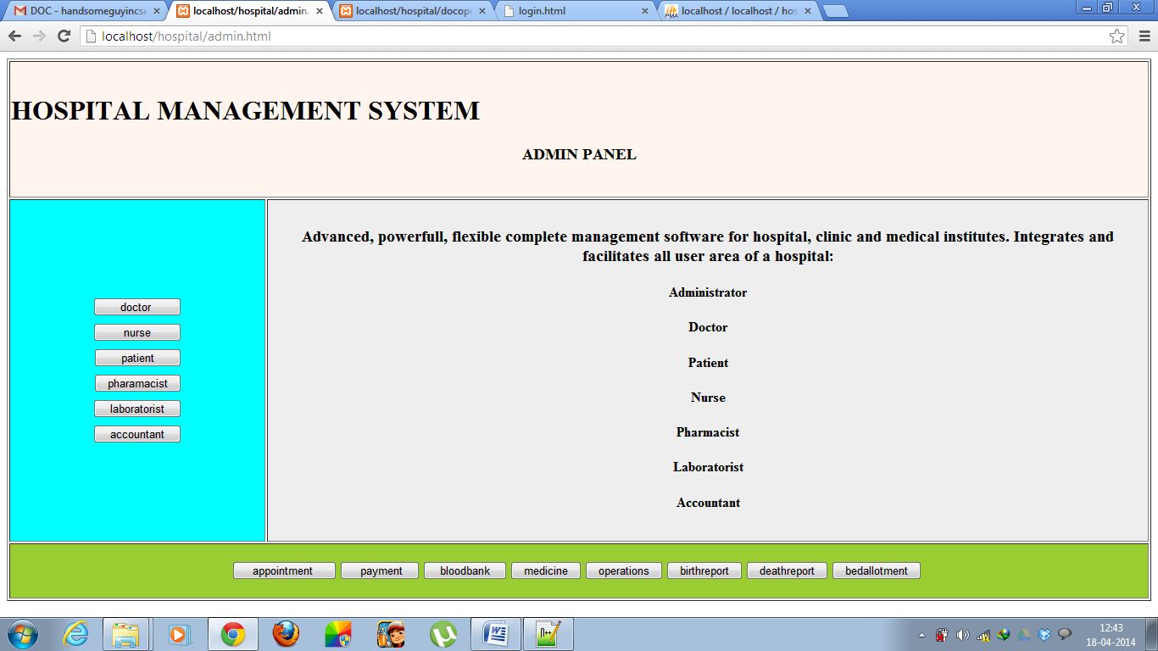

ADDING NEW EMPLOYEE DETAILS:
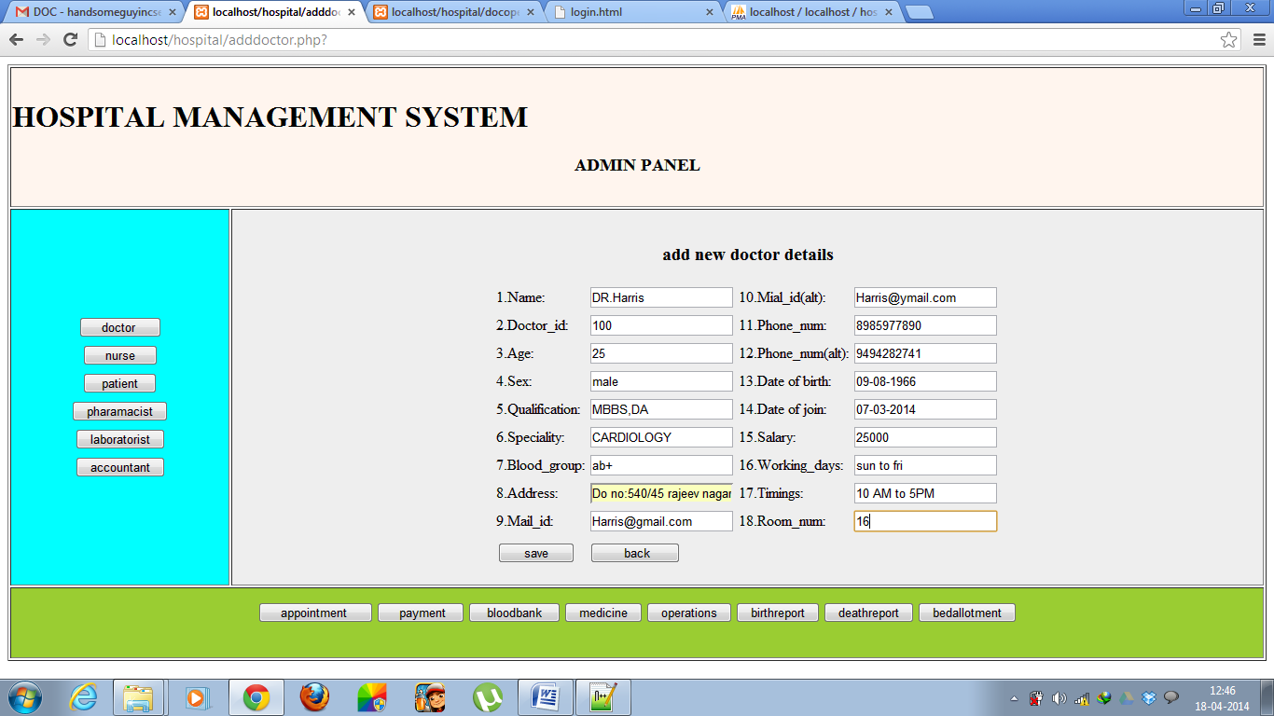

Doctor module:
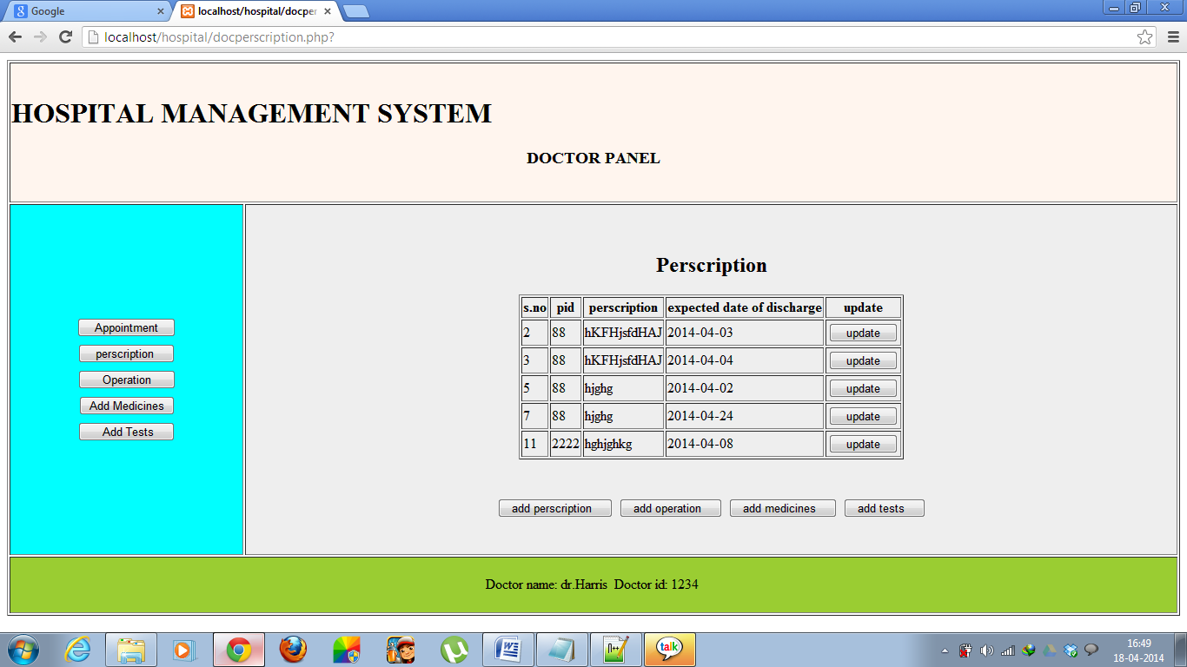

Operation details:
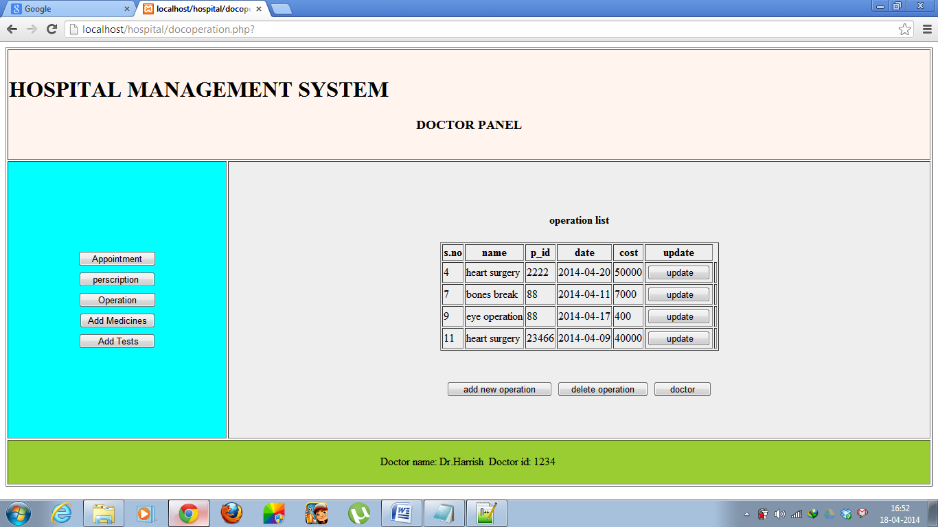

Create operation details:
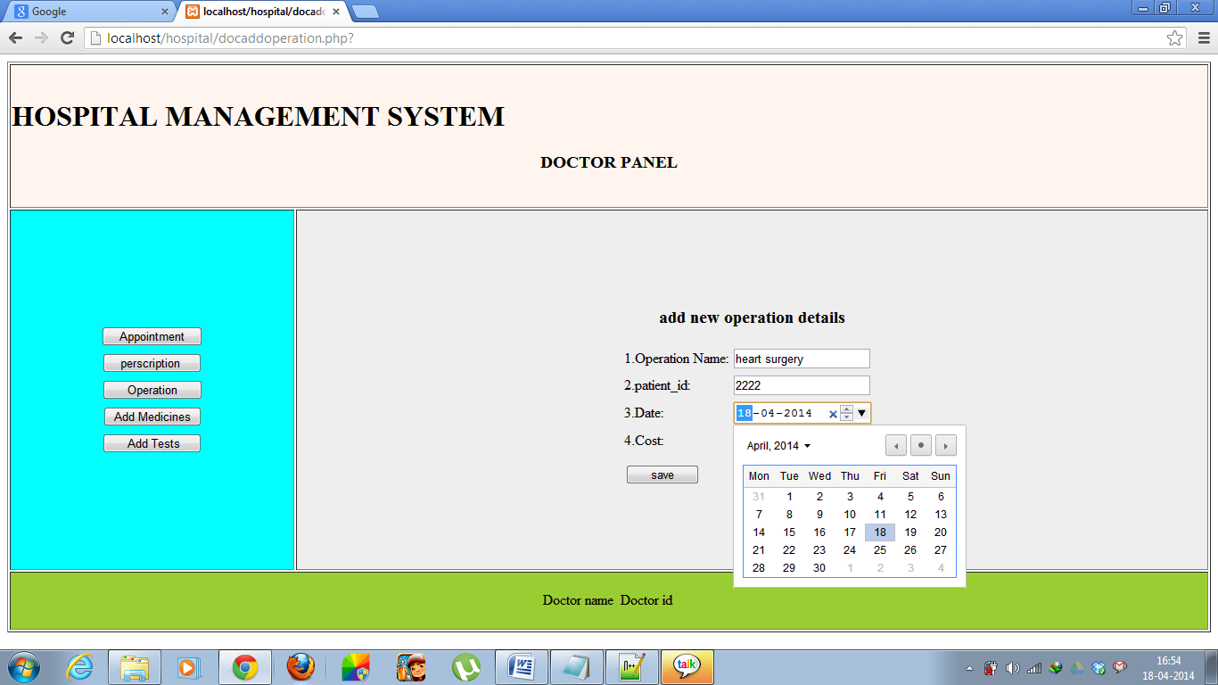

Add employee details:
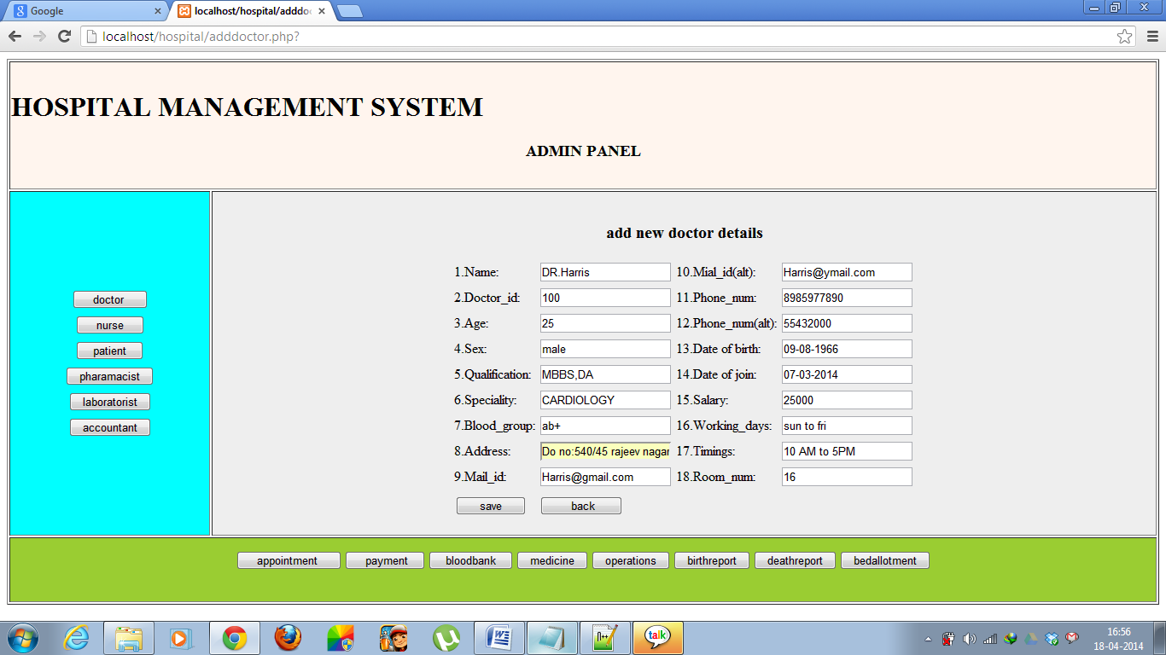

Bed allotment:
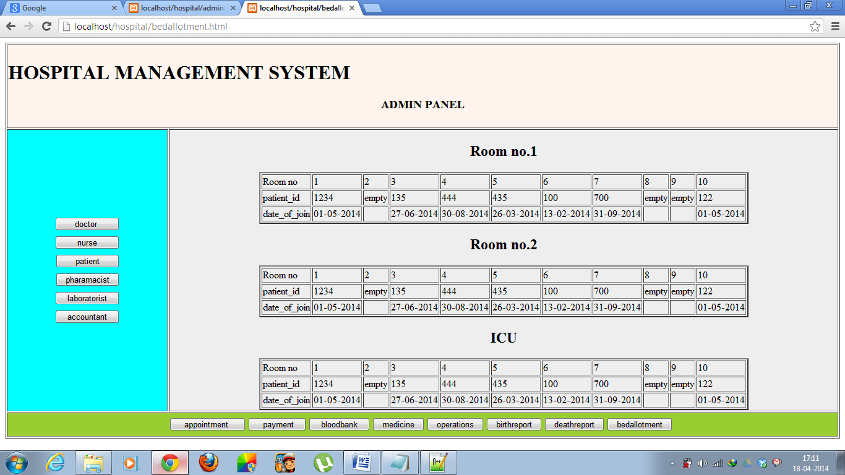

Patient registration form:
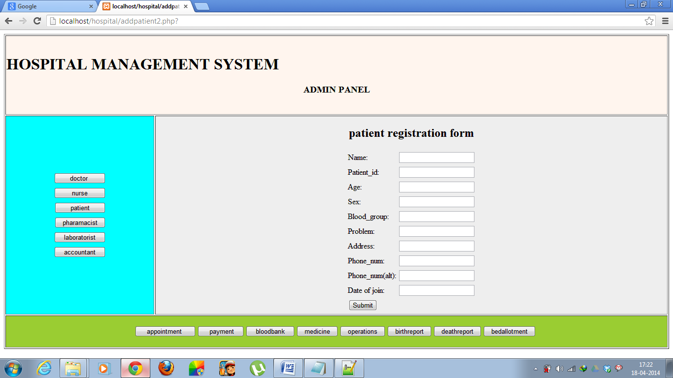

Blood status:
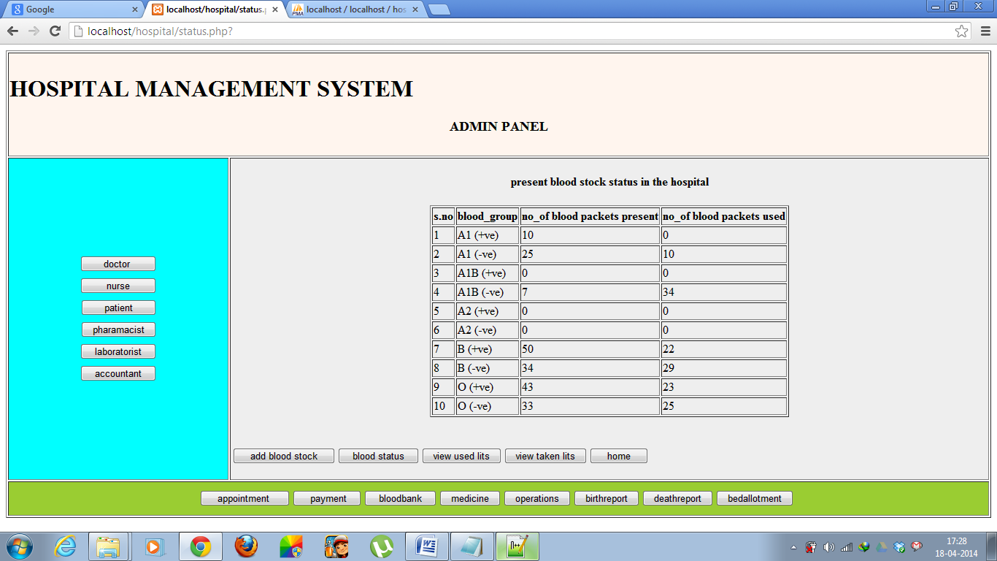

Appointments:
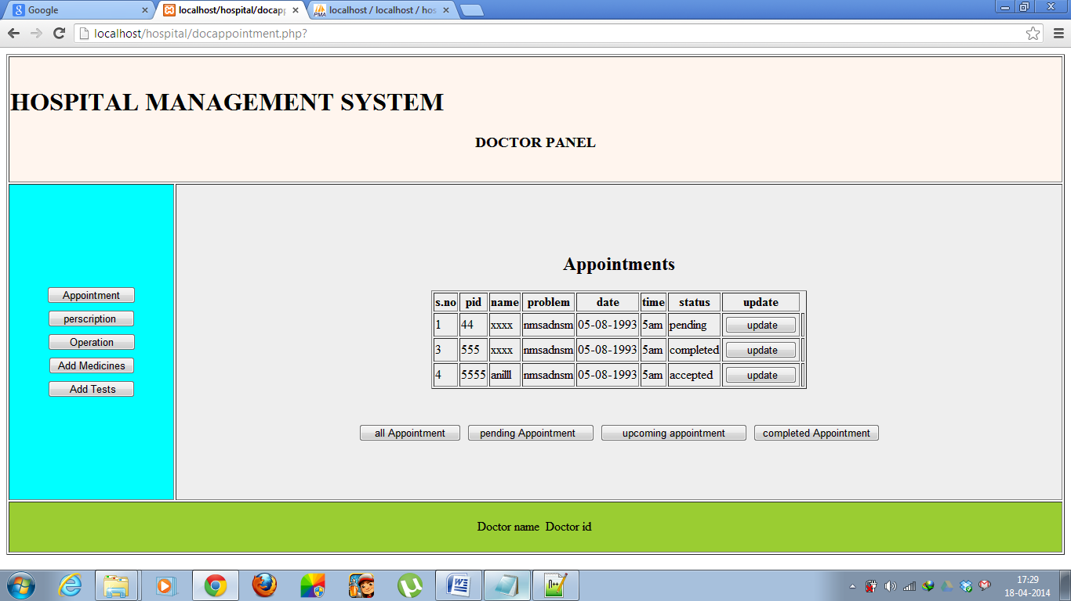

Payment details:
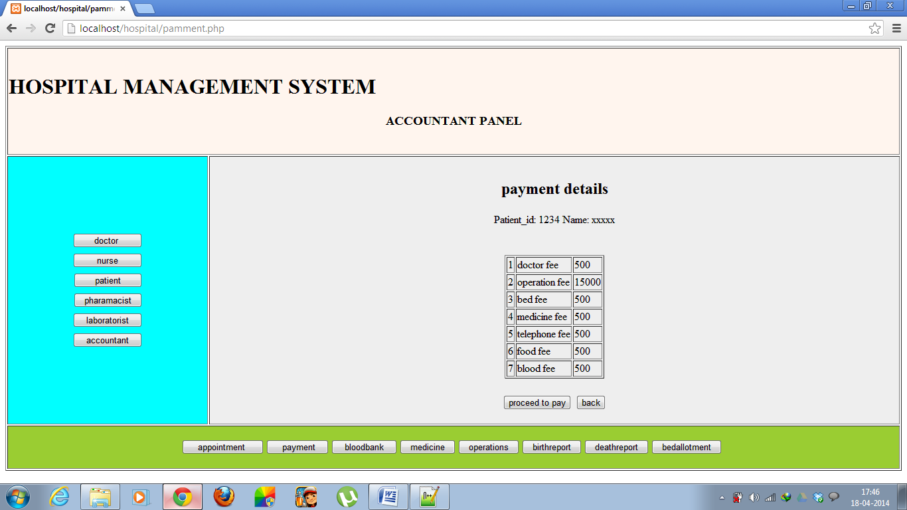

Birth report:
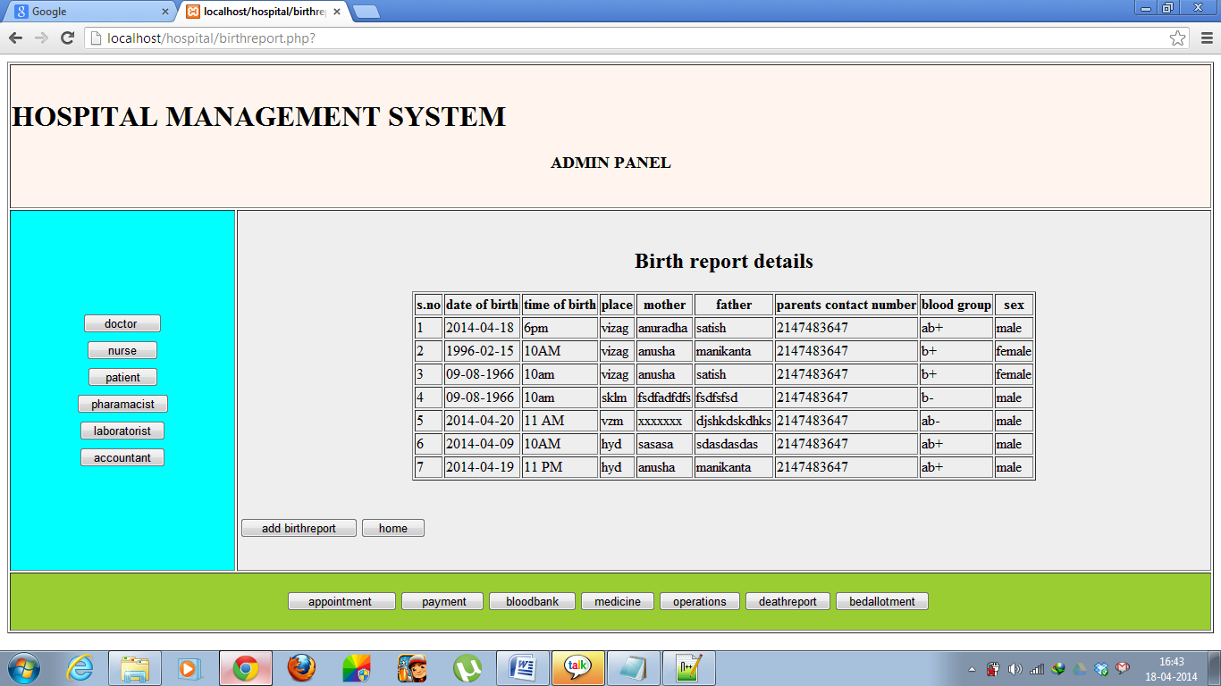

Death report:
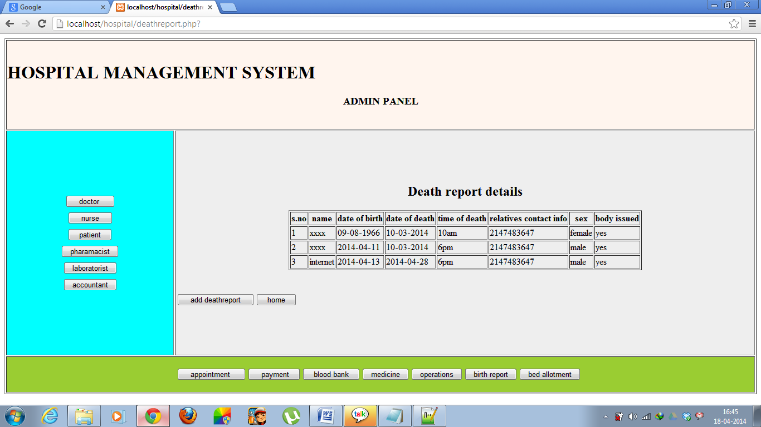

7.CONCLUSION

Since we are entering details of the patients electronically in the” Hospitals and medical facilities”, data will be secured. Using this application we can retrieve patient’s history with a single click. Thus processing information will be faster. It guarantees accurate maintenance of Patient details and facilities given by hospitals to him. It easily reduces the book keeping task and thus reduces the human effort and increases accuracy speed.

